How to Install Skype for Business at ncat.edu
Faculty and Staff of North Carolina A&T State University can install Skype for Business as well as the entire Office Product suite via your web office365 login.
Note that installing on a work PC will usually require a tech to assist due to permissions limits that prevent most users from installing software on University computers.
Those who use their own devices should not have that limitation.
Directions herein are focused on self-install on a windows PC you have sufficient rights on.

- Open a web browser to https://office365.ncat.edu and sign in:
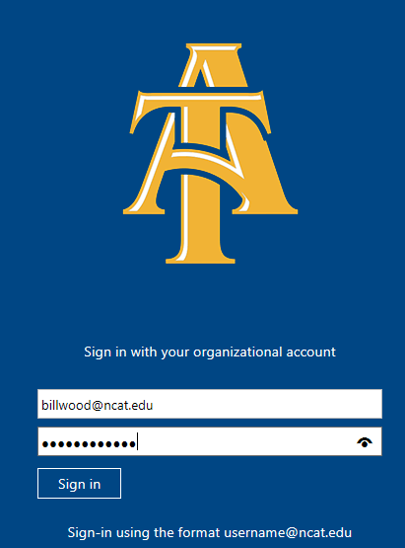

- One logged in, you have the option to install Office 365 – this will install on your computer Office 2013 that includes Skype for Business.
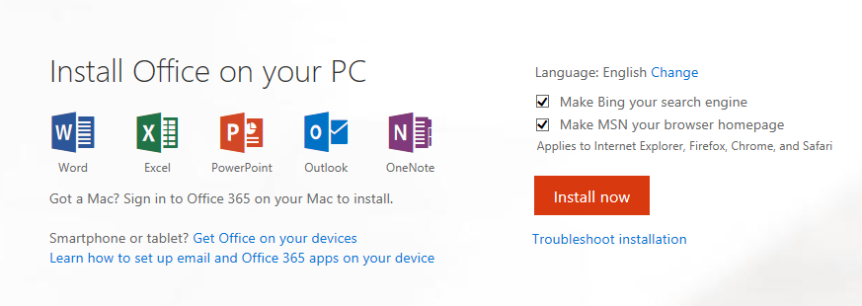

Note: If you have already installed Office on other devices, the above screen will look a bit different; look for this on the bottom of the screen:
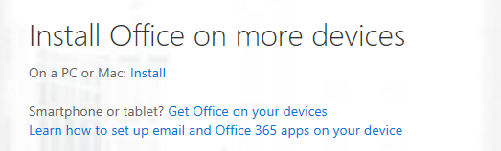

- As is typical with browsers, you will have to click some security dialogues as this:
- Click Run to continue.

- You may be presented with options, especially if you are doing additional installs.
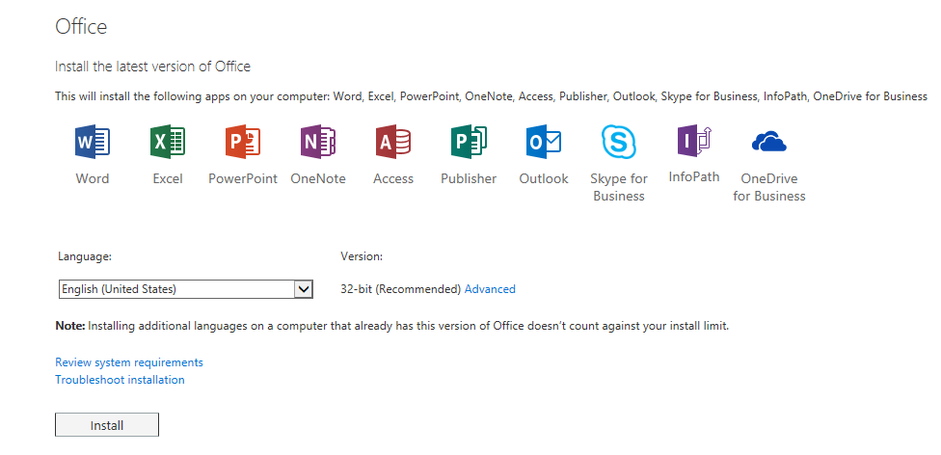
We recommend 32 bit even if you have 64 bit Operating System – it is rare to need 64 bit. Microsoft only recommends it for those dealing with extremely large data sets in Access or Excel.
- Caveats: The process that installs Office 2013 or 2016 also uninstalls all Office 2013 products. As you might expect, Word 2013, Excel 2013, and the rest of the Office suite are uninstalled. In addition, if a computer has InfoPath 2013, SharePoint Designer 2013, or certain versions of Visio 2013 or Project 2013 installed, installing Office 2016 also uninstalls those programs. You won’t be able to reinstall them.
- You may encounter a “remove older apps” error – follow this link; https://support.office.com/en-us/article/-We-need-to-remove-some-older-apps-error-a225347f-e102-4ea6-9796-5d1ac5220c3b?ui=en-US&rs=en-US&ad=US
- If you lack sufficient rights to install the software or need any other technical assistance, please visit https://aggiehelp.ncat.edu for KB articles and requesting services from Aggie Tech Support.

